**Microprocessor and Computer Architecture Laboratory**

**UE19CS256**

**4th Semester, Academic Year 2020-21**

Date: 24/1/21

|  |  |  |
| --- | --- | --- |
| Name: Adithya M S | SRN:PES1UG19CS027 | Section: A |

Week#____1_______Program Number: ____1___

Title of the Program

**Write an ALP using ARM instruction set to add and subtract two 32 bit numbers .Both numbers are in registers.**

1. ARM Assembly Code for each program
2. Final Output Screen Shot (Register Window, Output window)

The output should be verified with 2 test cases

(one example shown in class, one example of own choice)

Example1:

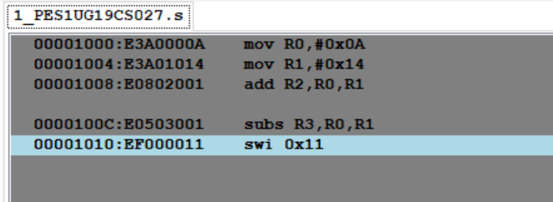

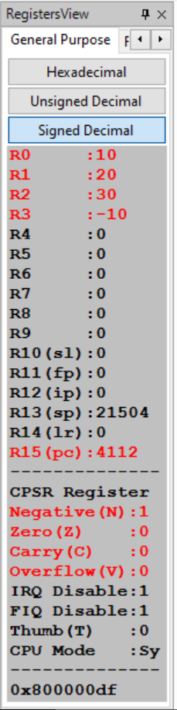

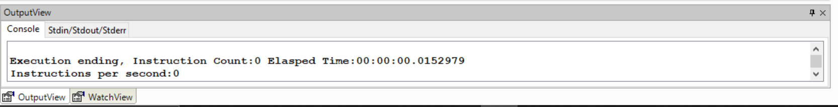

Example 2:

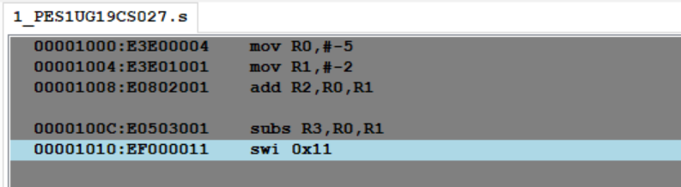

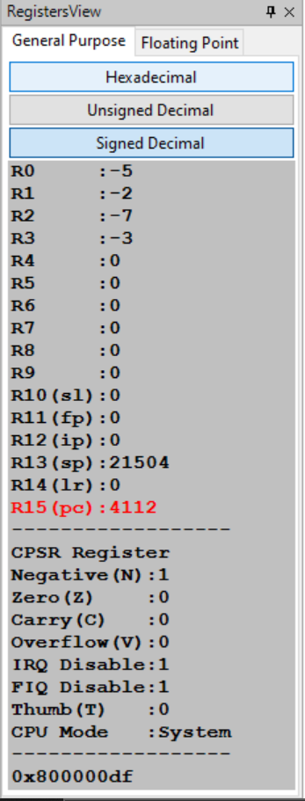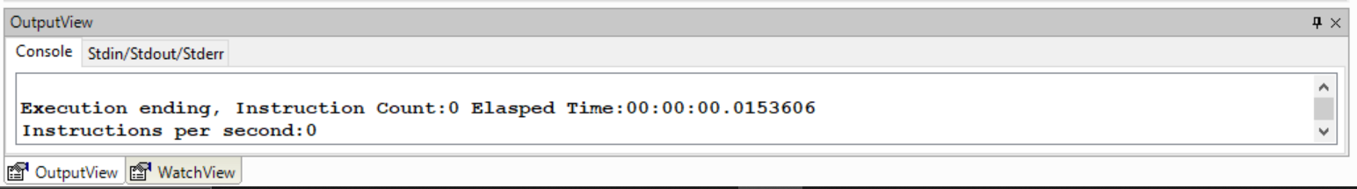

**Microprocessor and Computer Architecture Laboratory**

**UE19CS256**

**4th Semester, Academic Year 2020-21**

Date:24/1/21

|  |  |  |
| --- | --- | --- |
| Name: Adithya M S | SRN:PES1UG19CS027 | Section: A |

Week#____1_______ Program Number: ____2___

Title of the Program

**Write an ALP to demonstrate logical operations. All operands are in registers.**

1. ARM Assembly Code for each program
2. Final Output Screen Shot (Register Window, Output window)

The output should be verified with 2 test cases

(one example shown in class, one example of own choice)

Example 1:

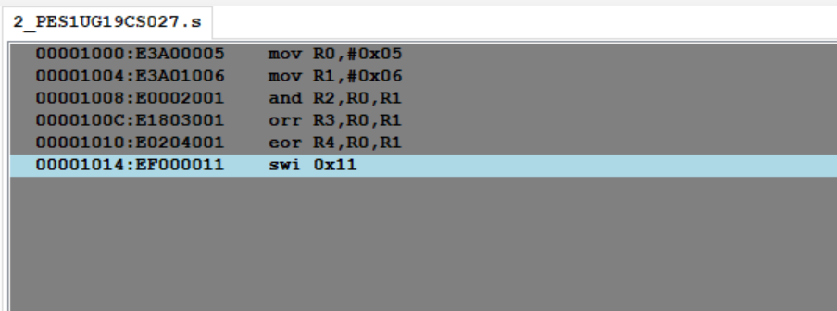

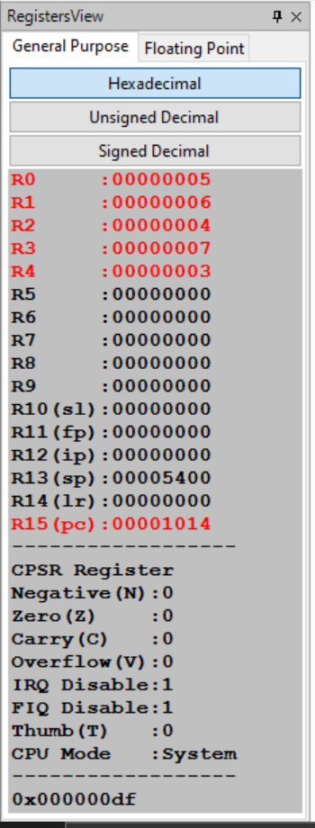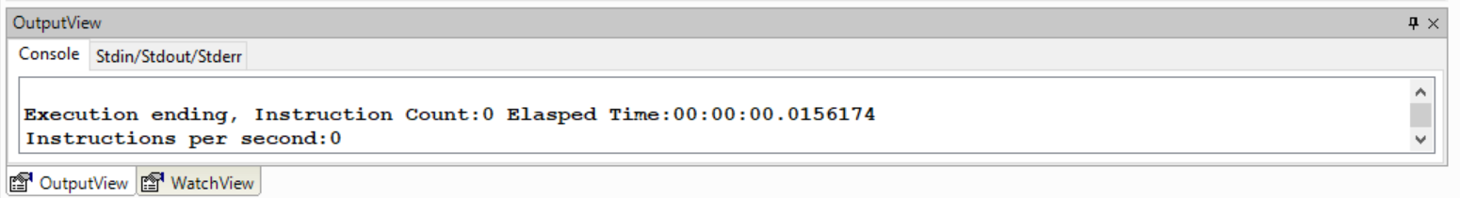

Example 2:

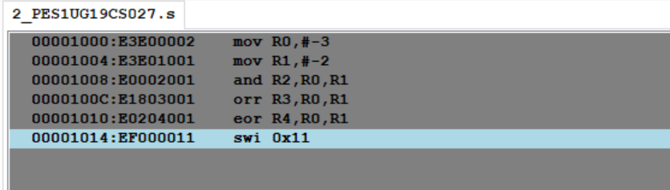

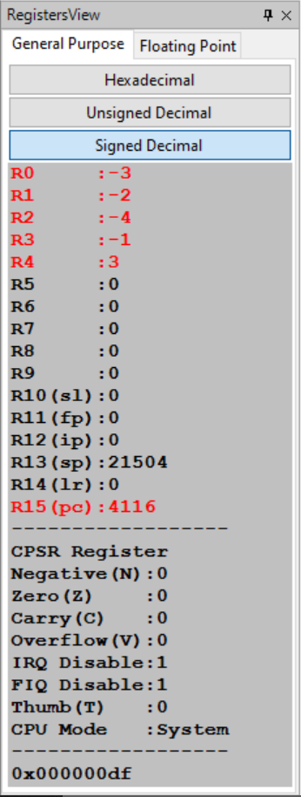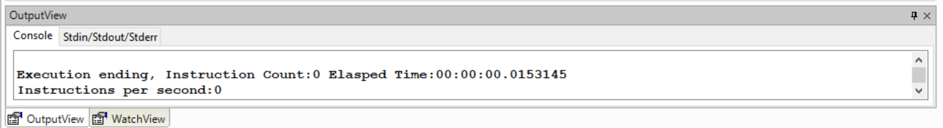

**Microprocessor and Computer Architecture Laboratory**

**UE19CS256**

**4th Semester, Academic Year 2020-21**

Date: 24/1/21

|  |  |  |
| --- | --- | --- |
| Name: Adithya M S | SRN: PES1UG19CS027 | Section: A |

Week#____1_______ Program Number: ____3___

Title of the Program

**Write an ALP to add 5 numbers where values are present in registers.**

1. ARM Assembly Code for each program
2. Final Output Screen Shot (Register Window, Output window)

The output should be verified with 2 test cases

(one example shown in class, one example of own choice)

Example 1:

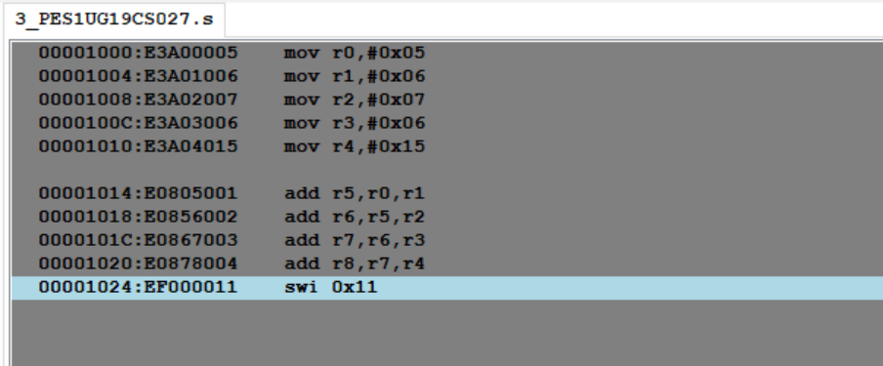

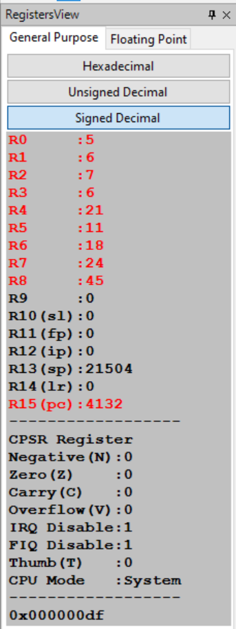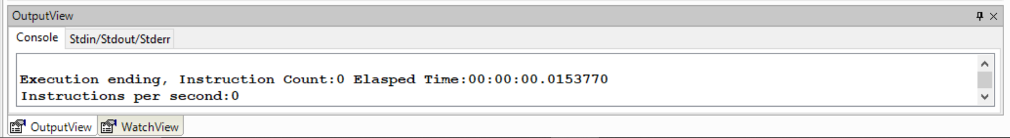

Example 2:

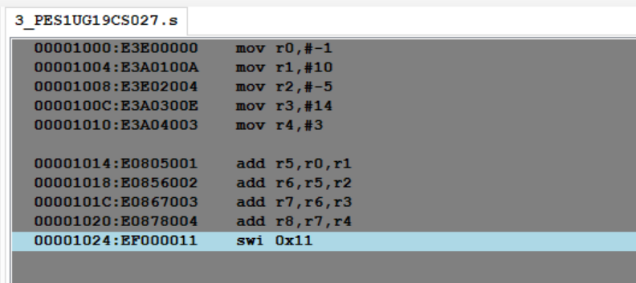

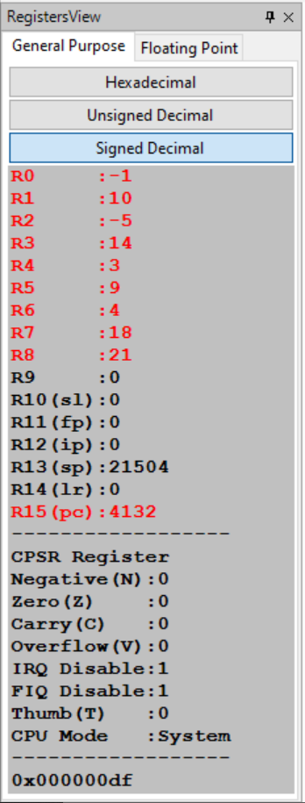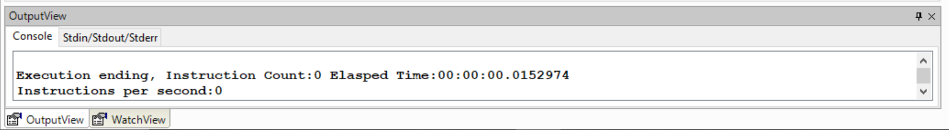

**Microprocessor and Computer Architecture Laboratory**

**UE19CS256**

**4th Semester, Academic Year 2020-21**

Date: 24/1/21

|  |  |  |
| --- | --- | --- |
| Name: Adithya M S | SRN: PES1UG19CS027 | Section: A |

Week#____1_______ Program Number: ____4___

Title of the Program

**Write an ALP using ARM instruction set to check if a number stored in a register is even or odd. If even, store 00 in R0, else store FF in R0**

1. ARM Assembly Code for each program
2. Final Output Screen Shot (Register Window, Output window)

The output should be verified with 2 test cases

(one example shown in class, one example of own choice)

**Example 1:**

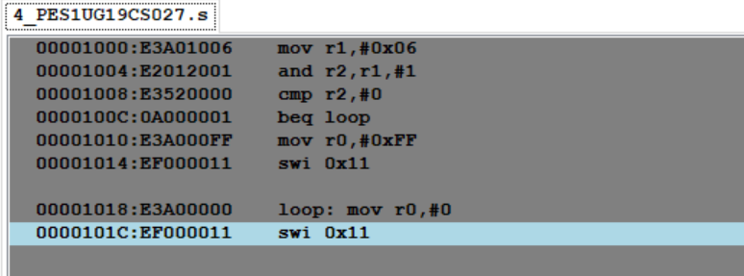

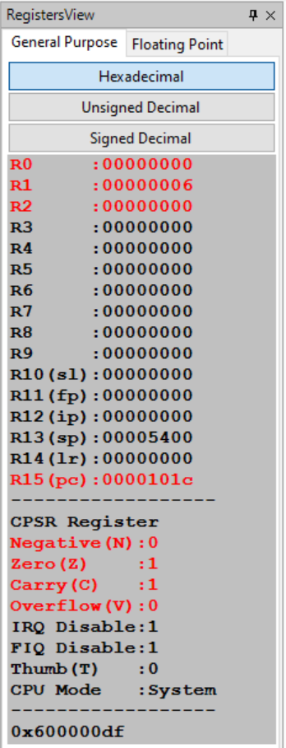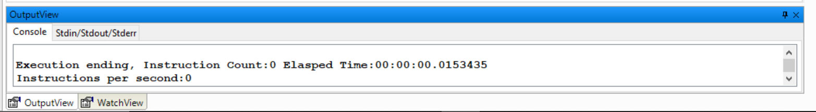

**Example 2:**

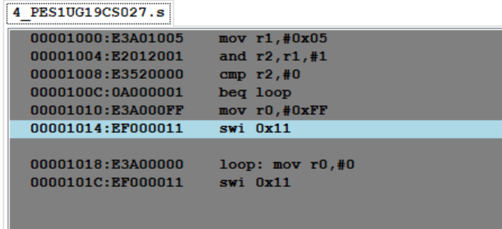

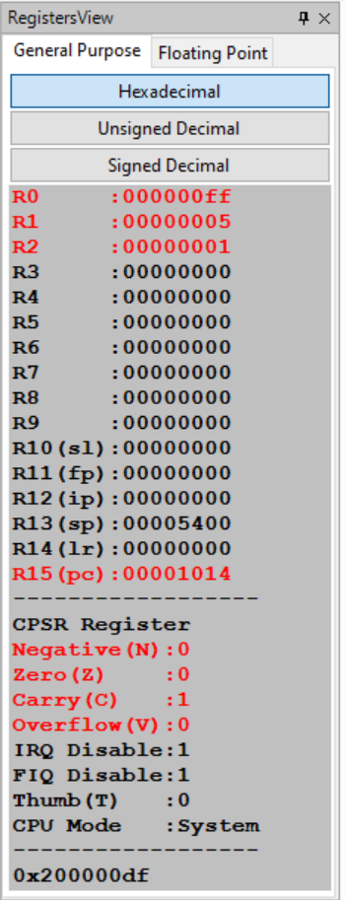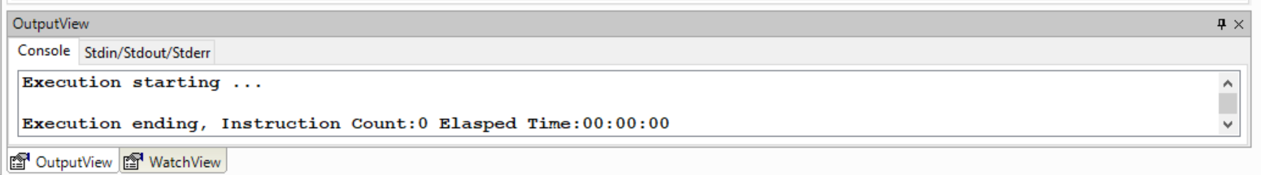

**Disclaimer:**

* The programs and output submitted is duly written, verified and executed by me.
* I have not copied from any of my peers nor from the external resource such as internet.
* If found plagiarized, I will abide with the disciplinary action of the University.

Signature:

Name: Adithya M S

SRN: PES1UG19CS027

Section: A

Date: 24/1/21